COME JUMP UP!™ WITH PATTY HALL

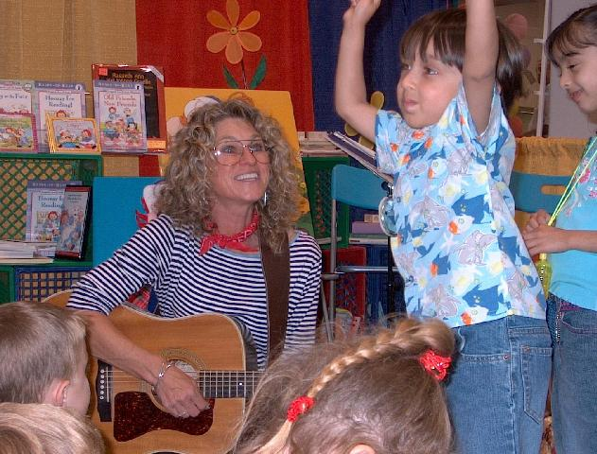

JUMPIN’ UP!™ SONGS
Down-Home Music for Modern Kids

DEL MAR PUBLIC LIBRARY

Wednesday, October 13, 2004
6:30 – 7:15 PM

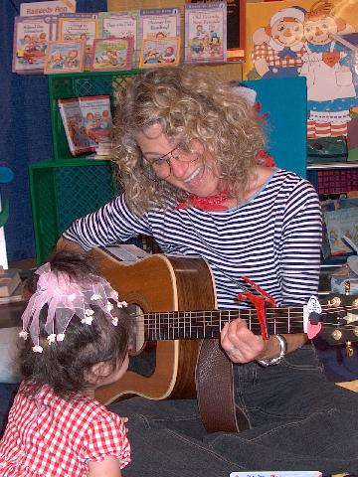

Tune up your voices and get ready to have some fun with folk music, as Patty Hall presents

JUMPIN’ UP!™ SONGS, her very own program of lively, kid-friendly songs on guitar and banjo.

And get ready to join in too, with instruments Patty brings for YOU to play along with. For kids of all ages, and their parents too! Hope to see you there. Oh yeah -- don’t forget to wear your JUMPIN’ UP! shoes!

The Del Mar Public Library is located at 1309 Camino del Mar in downtown Del Mar (at the corner of 13th). Call 858-755-1666 for more information. Program is FREE.
Patty’s books about Raggedy Ann & Andy will be for sale following the program.

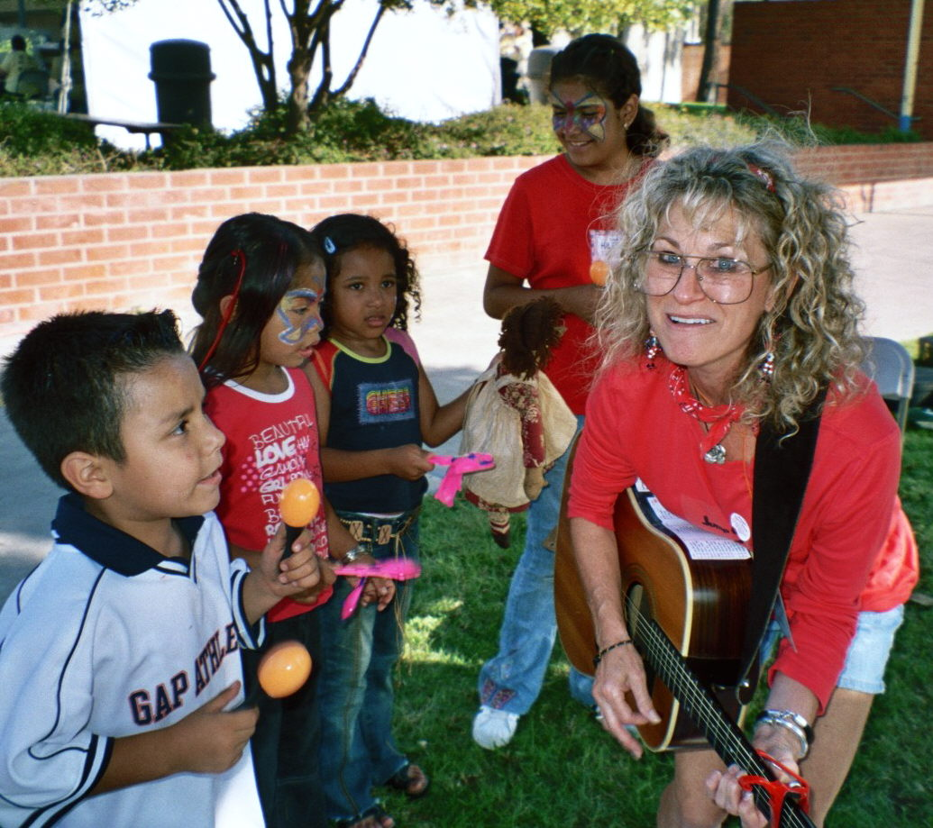

VISIT PATTY AT

www.pattyhall.com

